Assignment module 1
Section 1: Multiple Choice
1. Which of the following is NOT a component of the CPU?
1. ALU
2. RAM
3. CU
4. 1 and 3 both
ANS: 2.RAM
2. What is the function of RAM in a computer?
ANS:
It acts as the temporary storage for data and instructions that the CPU is currently using.
It is volatile memory, meaning all data is lost when the computer is powered off.
It provides fast read/write access, which makes program execution quicker compared to accessing data from hard drives or SSDs.
It is also know as primary memory or main memory.
It stores:
- The operating system (while running)
- Application programs (in use)
- Data currently being processed
3. Which of the following is a primary storage device?
1. HDD
2. SSD
3. SD card
4. 1 and 2 both
ANS: none of this is primary storage. This all are secondary storage.
4. What is the purpose of a GPU?
ANS :
Graphics Rendering 🎨
- Renders images, videos, and animations on the display.
- Handles tasks like shading, textures, and 3D modeling.
Offloading from CPU ⚡
- Takes over heavy graphical work so the CPU can focus on other tasks.
Parallel Processing 🔢
- Performs thousands of calculations simultaneously, which is useful for:
  - Gaming (smooth graphics & high frame rates)
  - Video editing & rendering
  - 3D design & CAD
  - Machine learning and AI training

Section 2: True or False
5. True or False: The motherboard is the main circuit board of a computer where other components are attached.
ANS: TRUE
6. True or False: A UPS (Uninterruptible Power Supply) is a hardware device that provides emergency power to a load when the input power source fails.
ANS: TRUE
7. True or False: An expansion card is a circuit board that enhances the functionality of a component.
ANS: TRUE

Section 3: Short Answer
8. Explain the difference between HDD and SSD.
ANS:
HDD | SSD
Uses spinning magnetic disks | Uses flash memory
Speed is slower | Speed is much faster
Less durable | More durable
Large size and heavier | Smaller size and lighter
Consume more power | Significantly consume less power
Cost per gb is less | Cost per gb is expensive
Fragmentation affect the performance | Fragmentation does not affect performance

9. Describe the function of BIOS in a computer system.
ANS:
full form of BIOS is Basic Input Output System
1. Hardware Initialization & POST (Power-On Self-Test)
The BIOS performs a series of diagnostic tests called the **Power-On Self-Test**. This checks the essential hardware components to ensure they are present and functioning correctly:
* CPU registers
* RAM (memory)
* Video card/display
* Keyboard
* Storage drives (HDD, SSD, optical)
BIOS will:
- Identify the CPU and its settings.
- Check the amount of RAM and test it.
- Activate the video card so you can see something on the monitor.
- Set up the system clock and other basic timers.

2. Bootstrap Loader (Bootstrapping)
After a successful POST, the BIOS searches for a bootable device containing an operating system loader. It checks devices in the order specified in the Boot Sequence/Order setting
3. Providing a Setup/Configuration Utility
The BIOS provides a built-in program, often called the BIOS Setup Utility or "CMOS setup," that allows users to configure low-level system settings.
We can configure:
  - System Time and Date
  - Boot Order (Which device to boot from first)
  - Hardware Settings (e.g., enabling/disabling ports, configuring SATA operation)
  - Security Features (e.g., setting a BIOS password)
  - System Performance Settings (e.g., overclocking)

10. List and briefly explain three input devices commonly used with computers.
ANS:
1. Keyboard
A keyboard is the primary device used for typing text, entering commands, and navigating a computer's interface. It consists of a set of keys arranged in a layout (most commonly QWERTY) that includes letters, numbers, punctuation, and special function keys (like Ctrl, Alt, Shift, Esc, and the F-keys). Users press these keys to input data directly into applications like word processors, web browsers, and spreadsheets.
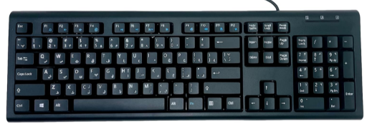
2. Mouse
A mouse is a handheld pointing device that allows a user to control a cursor (or pointer) on a computer screen. By physically moving the mouse across a flat surface (like a desk or mousepad), its internal sensor detects the motion and moves the on-screen cursor accordingly. A mouse typically has at least two buttons (left and right) for selecting, clicking, and opening items, and often includes a scroll wheel for navigating up and down within documents and web pages.
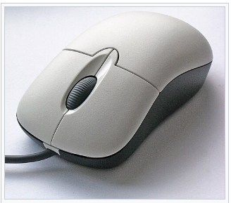
3. Webcam
A webcam is a small video camera that feeds its image in real-time to a computer. It is a crucial input device for video conferencing applications (like Zoom or Microsoft Teams), live streaming on platforms like Twitch, creating video content for YouTube, and for simple security monitoring.

Section 4: Practical Application
11. Identify and label the following components on a diagram of a motherboard:
● CPU
● RAM slots
● SATA connectors
● PCI-E slot

l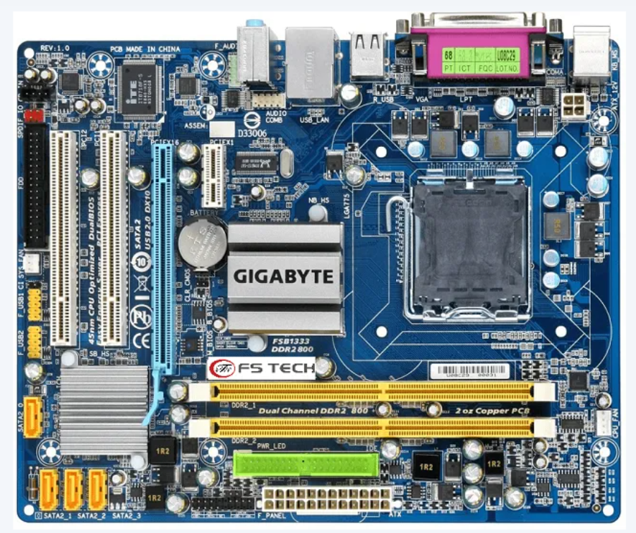

PCI-E slot CPU
sata connector
ram slots

12. Demonstrate how to install a RAM module into a computer.
ANS:
Step 1: Open the Computer Case
Step 2: Locate the RAM Slots
Step 3: Open the Retaining Clips
Step 4: Align and Insert the RAM Module
Step 5: Apply Firm, Even Pressure
Step 6: Close Up and Power On
Step 7: Verify the Installation

Section 5: Essay
13. Discuss the importance of proper cooling mechanisms in a computer system. Include examples of cooling methods and their effectiveness.
ANS:
- Performance Degradation (Thermal Throttling): Modern processors (CPUs) and graphics cards (GPUs) are designed with built-in safety mechanisms. When their temperature exceeds a safe operating threshold (typically around 90-100°C), they automatically reduce their clock speed and voltage to generate less heat. This process, known as thermal throttling, is a self-preservation measure. While it prevents immediate damage, it directly translates to a noticeable drop in performance. A game that should run at 100 frames per second (FPS) might stutter and drop to 40 FPS, or a video render might take significantly longer.
- System Instability and Crashes: Before thermal throttling kicks in, excessive heat can cause system instability. High temperatures can lead to electrical signal integrity issues, causing calculations to fail. This manifests as random program crashes, system freezes, unexpected reboots, and the infamous "Blue Screen of Death" (BSOD) in Windows. A system that is unstable is unreliable and frustrating to use.
- Reduced Component Lifespan: Consistently running components at high temperatures is like constantly running a car engine in the red zone—it dramatically shortens its life. Heat accelerates the degradation of electronic components. A phenomenon called electromigration, where metal atoms in the silicon are displaced by high current and heat, can eventually break the microscopic pathways in a CPU, leading to permanent failure. Similarly, capacitors on the motherboard and graphics card can dry out and fail prematurely under thermal stress.
- Permanent Damage and Data Loss: In extreme cases, a total cooling failure (e.g., a pump dying in a liquid cooler or a fan seizing) can cause temperatures to skyrocket so quickly that thermal throttling can't keep up. This can lead to catastrophic, permanent damage to the CPU, GPU, or motherboard, effectively "frying" the component. Furthermore, system crashes caused by overheating can lead to data corruption or loss if files were being written when the system went down.
Examples of Cooling Methods and Their Effectiveness
1. Air Cooling
- Method: Uses fans and heat sinks to dissipate heat into the surrounding air.
- Example: A CPU cooler with a heat sink and fan.
- Effectiveness:
  - Cost-effective and simple to maintain.
  - Sufficient for normal workloads and mid-range gaming PCs.
  - Limited effectiveness in high-performance systems due to airflow and temperature constraints.
2. Liquid Cooling
- Method: Circulates coolant (liquid) through tubes, transferring heat from components to a radiator where fans dissipate it.
- Example: Closed-loop all-in-one (AIO) coolers or custom liquid cooling loops for CPUs and GPUs.
- Effectiveness:
  - More efficient at transferring heat than air cooling.
  - Ideal for high-performance PCs, gaming rigs, and servers.
  - Quieter operation but more expensive and requires careful installation.
3. Passive Cooling
- Method: Uses heat sinks and natural convection (no fans).
- Example: Low-power devices (like routers, Raspberry Pi).
- Effectiveness:
  - Silent and reliable (no moving parts).
  - Limited to low-heat components, unsuitable for gaming PCs or servers.

14. Explain the concept of bus width and its significance in computer architecture.
ANS: In computer architecture, a bus is a communication system that transfers data between components inside a computer or between computers. Think of it as the digital highway or a set of wires that connects the CPU (Central Processing Unit), memory (RAM), storage drives, and peripherals.
Every piece of information that moves from one component to another—whether it's a program instruction, a value from a calculation, or a pixel for your screen—travels along one of these buses.
Defining Bus Width
Bus width refers to the number of individual wires (or parallel channels) within a single bus. It is measured in bits. A bus with a width of 8 bits has 8 parallel wires, a 32-bit bus has 32, and a 64-bit bus has 64.
This directly determines how much data can be transferred simultaneously in a single operation.
The Significance of Bus Width in Computer Architecture

1. Data Transfer Rate (Throughput)
This is the most direct and significant impact. The amount of data a bus can move per second is a product of its width and its operating speed (clock frequency).
A wider bus allows for a higher data transfer rate at the same clock speed. This means the CPU can fetch instructions and data from RAM faster, and the GPU can receive texture data more quickly. This directly reduces bottlenecks and increases overall system performance.
2. System Complexity and Cost
A wider bus is not without its drawbacks. Increasing the width of a bus makes the entire system more complex and expensive:
- More Pins: The CPU and memory modules need more physical pins to connect to the wider bus.
- More Complex Motherboards: The motherboard's printed circuit board (PCB) needs more layers and intricate traces (the "wires") to accommodate the extra connections, increasing manufacturing difficulty and cost.
- More Power Consumption: More wires switching on and off consume more power and generate more heat.
3. Addressable Memory Space
While the data bus carries the information, the address bus carries the location information (the memory address). The width of the address bus determines the total amount of memory the CPU can directly access.
The formula is: Total Addressable Memory = 2^(Address Bus Width)

